Italian unification 1858-70

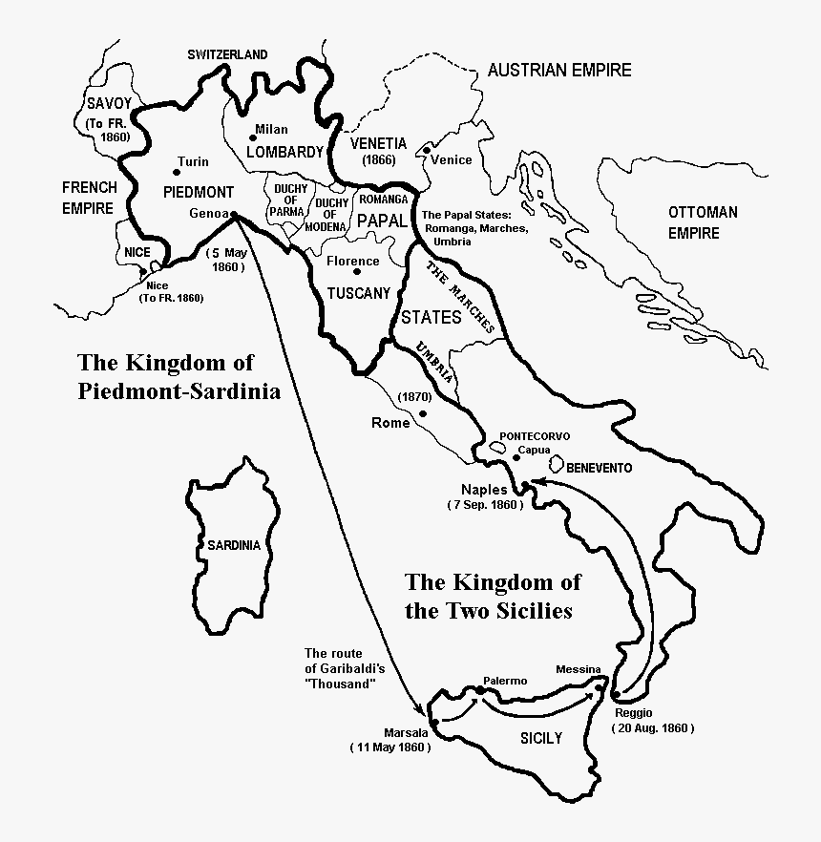

Key – which states were unified on which dates?

