Questions: WORLD WAR 1 Crash Course #36

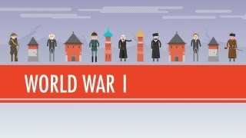

- What does host John Green blame for the start of World War I?

- Describe trench warfare. What was the experience of trench warfare like for the typical soldier in World War I? (NOTE: 2nd part of question appears later in video)

- In what ways was World War I truly a “world war” considering that the large majority of the fighting took place in Europe?

- How destructive/deadly was World War I? What were the major reasons why it was so deadly?

- Describe the outcome of World War I on the following nations… (a) Germany (b) Russia (c) the United States (d) the Ottoman Empire.

