Cheeseburger & chips
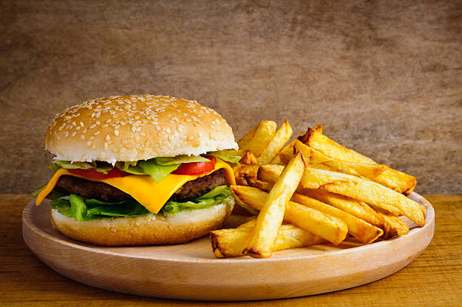

Ingredients for 5(ish..)
- 750g lean beef mince
- 1 medium onion, finely chopped
- 70g breadcrumb
- 100g mature cheddar, grated
- 1 tbsp Worcestershire sauce (optional)
- 1 egg, lightly beaten with a fork
- 1 tsp mild chilli powder &/or Tabasco (optional)
- 1-1.5kg potatoes ('frites' bags NOT 'potage', 'raclette' etc..)
- 1.5 tbsp plain flour
- 3-4 tbsp olive or sunflower oil
- Pack of 6 burger buns
- Pack of cheese slices
- Lettuce, sliced red onion, tomatoes, gherkins, sauces or relishes of your choice

Method
- Heat oven to 200C/180C fan.
- Peel potatoes and cut lengthways into long, thick chips
- Bring large saucepan of water to the boil
- Add the chips, bring the water back to the boil for 3-5 mins.
- After 3-5 mins, drain the potatoes well, tip onto large kitchen-paper covered trays.
- Scatter with the flour and some seasoning and gently toss to coat.
- In a baking tray, toss the chips in a little oil and seasoning
- Roast for 35-40 mins tossing occasionally until crisp and golden.

- Chop onion finely, whizz up bread into breadcrumbs, grate cheese, whip up egg
- Tip the mince into a large bowl with the onion, breadcrumbs, cheese, Worcestershire sauce, egg, chilli powder, salt & pepper.
- Mix together well with your hands, then divide the mixture into 5 (or 4....or 6!)
- Shape into burgers
(Optional - place a small amount of grated cheese in centre BUT seal well)
- Heat a griddle pan, grill or barbecue until hot
- Cook the burgers for about 6-7 mins on each side, or until cooked to your liking.

- Rinse, spin. chop salad, tomatoes, gherkins etc...
- Cut open your burger buns and grill open side for 30 secs or so at top of oven
- Add cheese slices to toasted side and put back under the grill for 10 secs or so..

- Take out chips from oven and add a generous amount of salt..
- Sandwich the burgers in toasted cheese buns
- Add salad and sauces, then serve with the chips.

